**Task 1: Arithmetic Operators**

1. **Create two variables a and b with numeric values.**
2. **Calculate the sum, difference, product, and quotient of a and b.**
3. **Print the results.**

​a=10  
b=20  
print(a+b)  
print(a-b)  
print(a*b)  
print(a/b)

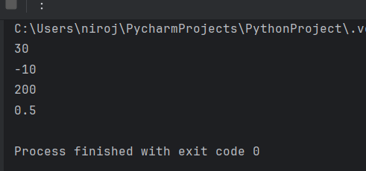Top of Form

Bottom of Form

**Task 2: Comparison Operators**

**1. Compare the values of a and b using the following comparison operators: &lt;, &gt;, &lt;=, &gt;=, ==,**

**and !=.**

**2. Print the results of each comparison**.

print(a<b)  
print(a>b)  
print(a<=b)  
print(a>=b)  
print(a!=b)

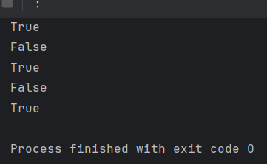

**Task 3: Logical Operators**

**1. Create two boolean variables, x and y.**

**2. Use logical operators (and, or, not) to perform various logical operations on x and y.**

**3. Print the results.**

x=True  
y=False  
print(x and y)  
print(x or y)  
print(not x)  
print(not y)  
print (not (x and Y))

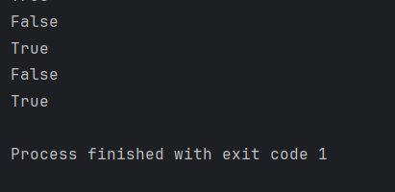

**Task 4: Assignment Operators**

**1. Create a variable total and initialize it to 10.**

**2. Use assignment operators (+=, -=, *=, /=) to update the value of total.**

**3. Print the final value of total.**

total = 10  
total += 5  
total -= 3  
total *= 2  
total /= 4  
print("Final value of total:", total)

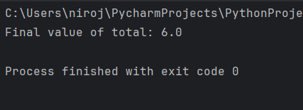

**Task 5: Bitwise Operators (Optional)**

**1. If you are comfortable with bitwise operators, perform some bitwise operations on integer**

**values and print the results. If not, you can skip this task.**

a = 10   
b = 4   
# Bitwise operations  
bitwise_and = a & b  
bitwise_or = a | b  
bitwise_xor = a ^ b  
bitwise_not_a = ~a  
left_shift = a << 2  
right_shift = b >> 1  
print(a&b)  
print(a|b)  
print(a^b)  
print(~a)  
print(a<<2)  
print(b>>1)

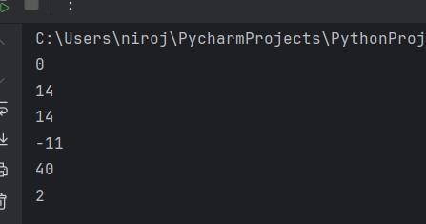

**Task 6: Identity and Membership Operators**

**1. Create a list my_list containing a few elements.**

**2. Use identity operators (is and is not) to check if two variables are the same object.**

**3. Use membership operators (in and not in) to check if an element is present in my_list.**

**4. Print the results.**

my_list=[7,22,98,76,36,87]  
print(2 is my_list)  
print(10 is not my_list)  
print(2 in my_list)  
print(100 not in my_list)  
list1=[1,2,4,5]  
list2=[3,4,5,6]  
print(list1 is list2)  
print(list1 is not list2)

